Welcome to Kindergarten
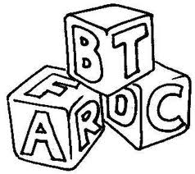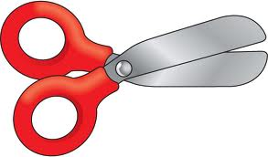

Thank you for attending the Heloise Lorimer Kindergarten Orientation! Listed below are a few strategies that you can practice with your child over the summer to help prepare them for their first Kindergarten experience in the fall. We have also attached materials that you can use to make learning fun.

Early Literacy Readiness skills (Books and Environmental Print)

Books:
As you and your child are reading books together, you may help your child by:
- Using the pictures to make a prediction about what the story might be about
- Having your child sound out initial and/or final letter sounds
- While reading, talk about letters. Bring your child’s attention to letter names and letter sounds.
- Pointing out similarities in words (initial sounds, rhyming words, etc)
- Helping your child to track underneath the words with their finger as they read
- Encouraging your child to use the pictures to help decode the words/sentences
- Encouraging your child to retell the story in its own way. (Even if it isn’t 100% correct be sure to praise their imagination.)
- When you finish reading the book, have a conversation about why your child did or didn’t enjoy the book.
- Check out www.starfall.com. This is a fun, educational website and/or app that reinforces early literacy skills.

Environmental Print:
- When you are out and about or while simply enjoying breakfast, bring your child’s attention to the fact that letters are everywhere. These times are great opportunities to point out print in your child’s environment. For example when you come to a STOP sign talk with them about how S,T,O,P spells stop. Another example would be, what sound does the letter M make? Think about the beginning sound in McDonalds? Cereal boxes are another great way to search for letters. Show them a letter then have them search for that letter on the cereal box.

Fine Motor

- Working with playdough will help your child to build the hand strength and coordination needed for writing.
- Explore rolling and flattening the playdough to make the letters in their name.
- Explore rolling the playdough into snakes and different size balls.
- When teaching your child to use scissors it is important to reinforce proper positioning; Always thumb up, elbows tucked by your sides. (Thumb to the sun!)
- Draw straight and curvy lines on old flyers and have your child cut them out. * If your child is having a difficult time keeping their elbows by their sides, tape a piece of paper up on the wall and have them cut from a standing position.
- Have your child cut out pictures from old magazines and newspapers, then glue them onto paper.
- Have your child stick pipe cleaners into each hole of a kitchen strainer.
- Have your child practice beading with large pony beads onto a pipe cleaner.
- See attached sheet for proper letter and number formation.
Numeracy

- Have your child order magnetic numbers on the fridge from 0-10.
- Have your child match the magnetic numbers to a group of objects.
- Practice sorting at home. Have your child help you sort the laundry, sort the crayon box by colour, sort the kitchen utensils, sort lego by size and/or colour.
- Try to notice and identify patterns in our world. On our clothing, wallpaper, beaded jewellery etc.

